## **PRACTICAL 5,6:**

# **AIM :** Threading

**PROGRAM 1:**

Write a program to find prime number in a given range using both method of multithreading.

**Source code:**

import java.util.*;

class Prime implements Runnable

{Thread t;

public int start,end,num;

Prime(int s,int e)

{

start=s;

end=e;

t=new Thread(this);

t.start();

}

public void run()

{

for(num=start;num<=end;num++)

{

int i;

for(i=2;i<num;i++)

{

if(num%i==0)

break;

}

if(i==num)

System.out.println(num + "\n");

}

}

}

**PROGRAM 2:**

Write a program to increment the value of one variable by one and display it after one second using thread.

**Source code:**

package lab5;

public class Incr implements Runnable

{

public Thread t;

public int i=1;

public Incr()

{

t=new Thread(this,"one");

t.start();

}

public void run(){

while(true){

try{

System.out.println(i++);

Thread.sleep(1000);

}

catch(Exception e)

{

System.out.println("caught");

}

}

}

}

**PROGRAM 3:**

Assume one class Queue that defines queue of fix size says 15.

* Assume one class producer which implements Runnable, having priority NORM_PRIORITY +1
* One more class consumer implements Runnable, having priority NORM_PRIORITY-1
* Class TestThread is having main method with maximum priority, which creates 1 thread for producer and 2 threads for consumer.
* Producer produces number of elements and put on the queue. when queue becomes full it notifies other threads.

Consumer consumes number of elements and notifies other thread when queue become empty.

**Source code:**

class clicker implements Runnable

{

int click=0;

Thread t;

private volatile boolean running = true;

public clicker(int p)

{

t=new Thread(this);

t.setPriority(p);

}

public void run()

{

while(running)

{

click++;

}

}

public void stop()

{

running=false;

}

public void start()

{

t.start();

}

}

**Main class to run all programs according to choice:**

package main;

import lab5.*;

import java.util.Scanner;

public class Main56

{

public static void prime() throws Exception

{

new Prime(100,200);

}

public static void incre()

{

try

{

new Incr();

}

catch(Exception e)

{

System.out.println("caught");

}

}

public static void HiLopri()

{

Thread.currentThread().setPriority(Thread.MAX_PRIORITY);

clicker hi=new clicker(Thread.NORM_PRIORITY +2);

clicker lo=new clicker(Thread.NORM_PRIORITY -2);

lo.start();

hi.start();

try

{

Thread.sleep(10000);

}

catch(InterruptedException e)

{

System.out.println("Main thread interrupted.");

}

lo.stop();

hi.stop();

try

{

hi.t.join();

lo.t.join();

}

catch(InterruptedException e)

{

System.out.println("interruptedException caught");

}

System.out.println("Low-priority thread:"+lo.click);

System.out.println("High-priority thread:"+hi.click);

}

public static void main(String a[]) throws Exception

{

int ch;

Scanner ob=new Scanner(System.in);

System.out.println("\n1.Find Prime\n2.Increment variable\n3.set Queue priority\n");

System.out.println("Enter your choice: ");

ch = ob.nextInt();

switch(ch)

{

case 1:prime();

break;

case 2:incre();

break;

case 3:HiLopri();

break;

default:

System.out.println("enter a valid choice");

}

}

}

**Output:**

For program 1:

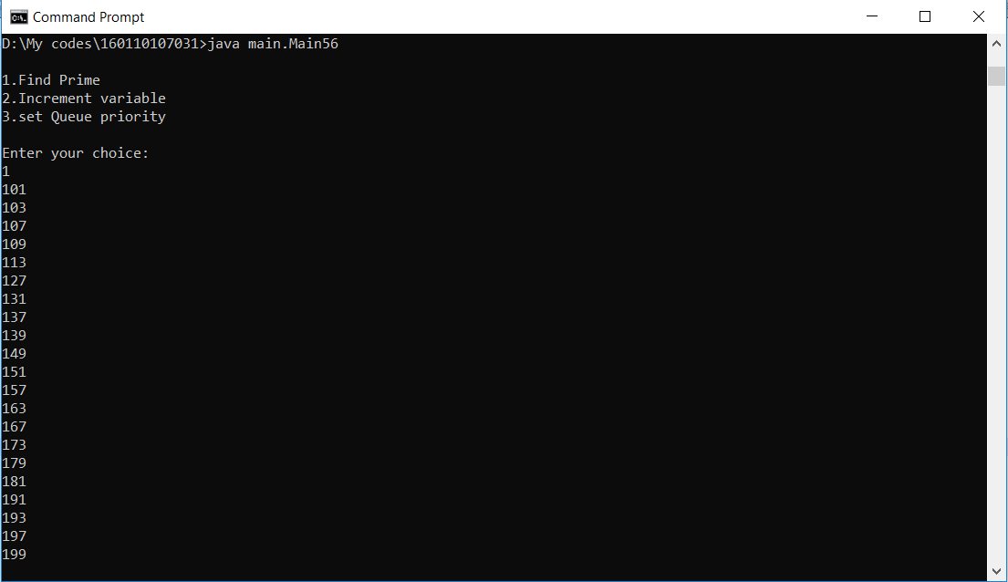

For program 2:

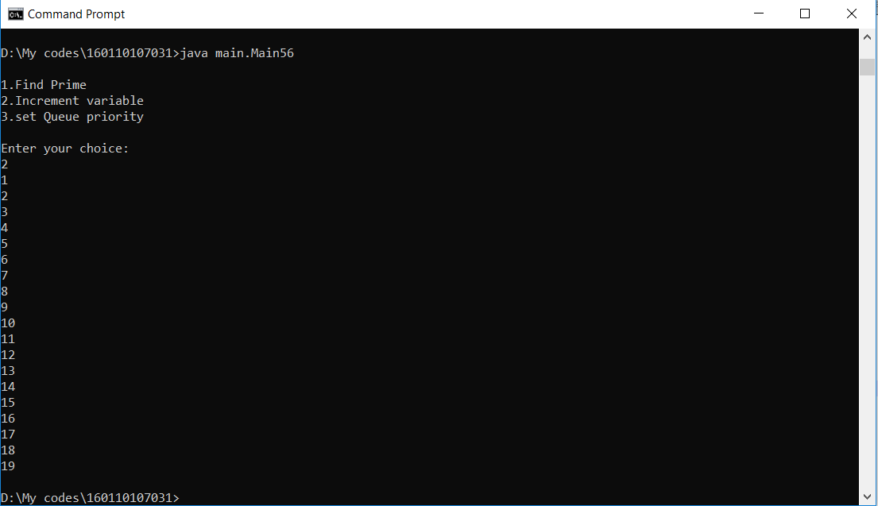

For program 3:

